# Api.py:

LAB 07

from flask import Flask, jsonify, render_template, request

app = Flask( name ) std = [

{

"SrNo": 1,

"RollNum": "18b-119-se", "Name": "Javeria Mughal"

},

{

"SrNo": 2,

"RollNum": "18b-081-se", "Name": "Summaiya Saeed"

},

{

"SrNo": 3,

"RollNum": "18b-029-se", "Name": "Syeda Maham Wadood"

}

]

@app.route('/') def index():

return render_template('index.html')

@app.route('/api/showall') def show():

return jsonify(std)

@app.route('/api/show', methods=['GET']) def id():

id = int(request.args['id']) detail=[]

for student in std:

if student['SrNo'] == id: detail.append(student)

if len(detail) == 0: return "Unknown ID"

else:

return jsonify(detail)

if name == ' main ': app.run(debug=True)

# Index.html:

<!DOCTYPE html>

<html lang="en">

<head>

<meta charset="UTF-8">

<title>New API Implementation</title>

</head>

<body>

project launched successfully !!

</body>

</html>

## To show specific id:

http://127.0.0.1:5000/api/show?id=2

**To show all json records:**

**http://127.0.0.1:5000/api/showall**

LAB TASK

# By using Flask and Flask restful:

from flask import Flask

from flask_restful import Api, Resource, reqparse, abort app = Flask( name )

api = Api(app)

std_put = reqparse.RequestParser() std_put.add_argument("Name",type=str) std_put.add_argument("RollNum",type=str)

students={1:{"Name":"Javeria Mughal","RollNum":"18b-119-se"}, 2:{"Name":"Summaiya Saeed","RollNum":"18b-081-se"},

3:{"Name":"Syeda Maham Wadood","RollNum":"18b-029-se"},

4: {"Name": "Agha Muqarrib", "RollNum": "18b-080-se"},

5: {"Name": "Mansoor Ahmed", "RollNum": "18b-125-se"}

}

def notFound(std_id):

if std_id not in students:

abort(404, message="Student id not found!") class std(Resource):

def get(self, std_id):

notFound(std_id)

return students[std_id] def put(self,std_id):

newStd=std_put.parse_args()

students[std_id]=newStd return students[std_id]

def delete(self, std_id): del students[std_id] return '', 204

api.add_resource(std,"/show/<int:std_id>") if name == ' main ':

app.run(debug=True)

#requestRoute

# See PyCharm help at [https://www.jetbrains.com/help/pycharm/](http://www.jetbrains.com/help/pycharm/)

**OUTPUT “GET” FUNCTION:**

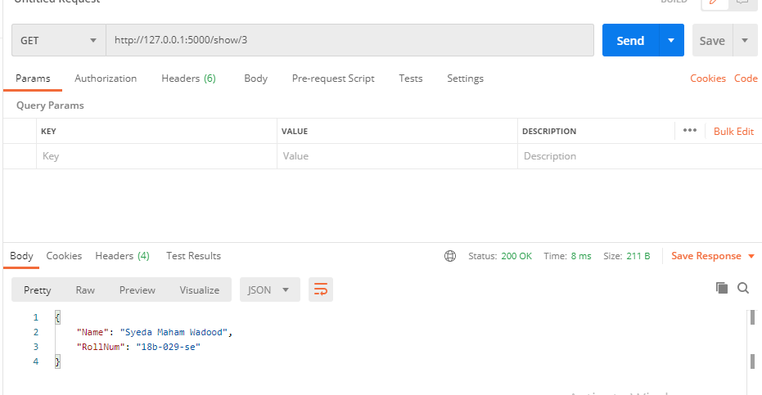

**OUTPUT “PUT” FUNCTION:**

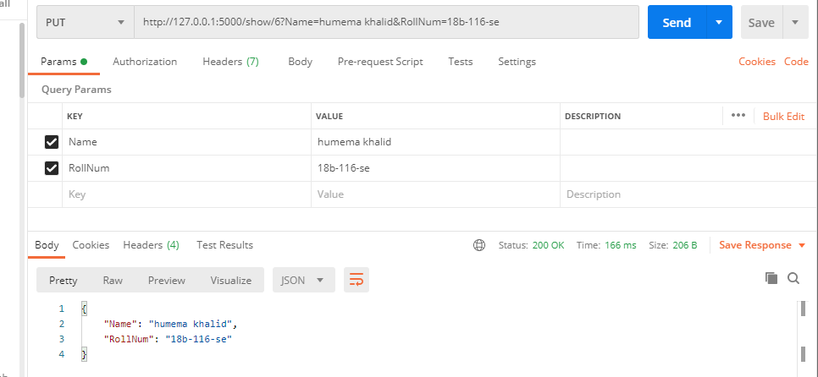

**OUTPUT “DELETE” FUNCTION:**

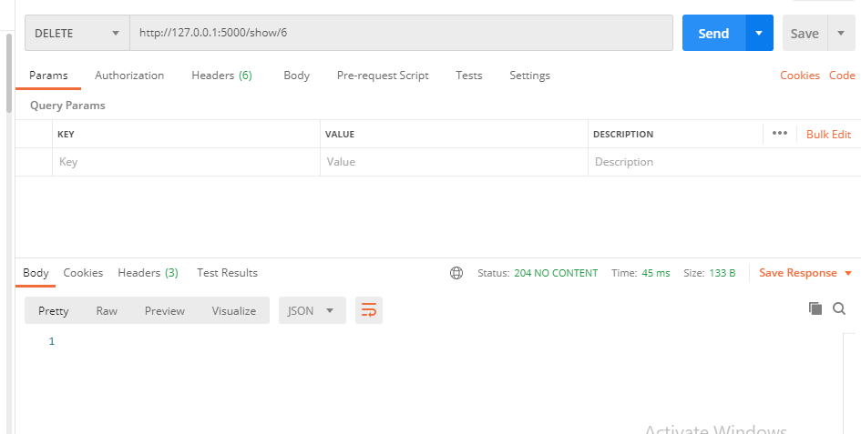

After deleting data

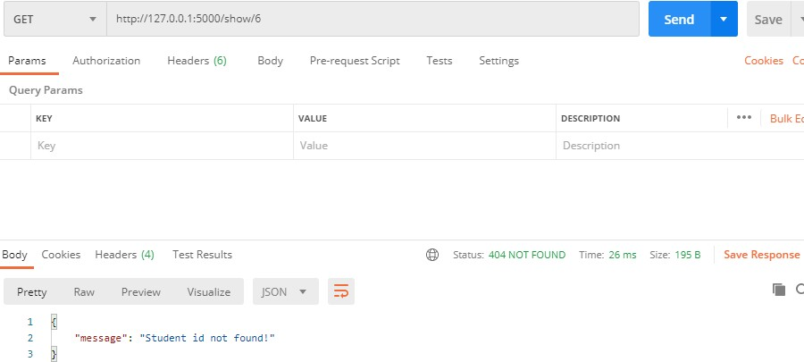

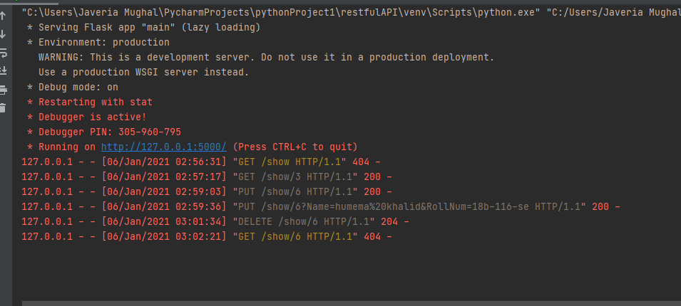

**# To show results In postman app: by using GET,DELETE,POST FUNCTIONS:**

http://127.0.0.1:5000/show/3